The Republic of Korea’s views on Article 6, paragraph 4, of the Paris Agreement referred to in paragraph 10 of decision -/CMA.4

- Introduction
Pursuant to paragraph 10 of decision -/CMA.4, the Republic of Korea (ROK) is pleased to submit its views on the matters referred to in paragraph 9 of decision -/CMA.4. The matters on which Parties have been called on to provide their views are as follows:

(a) Consideration of whether Article 6, paragraph 4, activities could include emission avoidance and conservation enhancement activities;
(b) Connection of the mechanism registry to the international registry as per paragraph 63 of the rules, modalities and procedures for the mechanism, as well as to other registries referred to in decision 2/CMA.3, annex, paragraph 29, if applicable, including the nature and extent of interoperable features;
(c) Provision of a statement by the host Party to the Supervisory Body specifying whether it authorizes Article 6, paragraph 4, emission reductions issued for an Article 6, paragraph 4, activity for use towards achievement of nationally determined contributions and/or for other international mitigation purposes, as defined in decision 2/CMA.3, in accordance with paragraph 42 of the rules, modalities and procedures, including its timing, relevant information on the authorization and any revisions;

Regarding the interoperability between registries, the ROK would like to recall our views expressed in our previous submissions particularly the infrastructure section which was submitted in September 27th, 2022.

- Emission avoidance and conservation enhancement activities
In our view, there is no clear definition or a mutually agreed understanding as to what exactly ‘emission avoidance’ and ‘conservation enhancement’ activities refer to. Without a clear definition of emission avoidance and conservation enhancement activities, Parties cannot properly consider what activities can be regarded as emission avoidance and conservation enhancement activities and whether such activities can be counted as Article 6, paragraph 4, activities. It is therefore important to first establish a clear definition of emission avoidance and conservation enhancement activities and then a common understanding of what activities fit such a definition and might hence be regarded as emission avoidance and conservation enhancement activities. Constructive discussions on whether emission avoidance and conservation enhancement activities could be included in Article 6, paragraph 4, activities are possible only after Parties have a shared understanding of what such activities are.
Parties who intend to participate in such activities should provide a definition of emission avoidance and conservation enhancement activities and a list of such activities that should, in their view, be included in Article 6, paragraph 4, activities. Once we have such a definition and a list of potential emission avoidance and conservation enhancement activities, we can fruitfully consider whether and which of such activities could be included in Article 6, paragraph 4, activities.
Furthermore, in our view, proper consideration of potential inclusion of emission avoidance and conservation enhancement activities into Article 6, paragraph 4, activities involve a careful assessment of whether such activities can meet the design requirements stipulated in paragraph 31 of the annex of the rules, modalities and procedures for the mechanism established by Article 6, paragraph 4, of the Paris Agreement (hereinafter RMP). Those design requirements seem to be a particularly relevant basis on which to base our consideration. It is highly probable, in our view, that emission avoidance and conservation enhancement activities, by their very nature, are inherently incompatible with the activity design requirements. Parties’ expressed reservations regarding the inclusion of emission avoidance and conservation enhancement activities into Article 6, paragraph 4, activities largely stem from their concerns about a fundamental incompatibility between such activities and the activity design requirements. Paragraph 30 of the RMP provides that to be registered as an Article 6, paragraph 4 activity, an activity shall be designed according to the requirements in the RMP. The ROK thinks that the following design requirements are particularly relevant for our discussion:
The activity shall:
- Be designed to achieve mitigation of GHG emissions that are additional, including reducing emissions, increasing removals and mitigation co-benefits of adaptation actions and/or economic diversification plans, and not lead to an increase in global emissions; (paragraph 31(a))
- Deliver real, measurable and long-term benefits related to climate change in accordance with decision 1/CP.21, paragraph 37(b); (paragraph 31(d.i)
- Minimize the risk of non-permanence of emission reductions over multiple NDC implementation periods and, where reversals occur, ensure that these are addressed in full; (paragraph 31(d.ii))
- Minimize the risk of leakage and adjust for any remaining leakage in the calculation of emission reductions or removals; (paragraph 31(d.iii))
- Minimize and, where possible, avoid negative environmental and social impacts; (paragraph 31(d.iv))

To be included in Article 6, paragraph 4, activities, emission avoidance and conservation enhancement activities must be shown to be compatible with those design requirements. In this regard, the ROK welcomes a synthesis report on the submissions and the technical expert dialogue to be held between the fifty-eighth and fifty-ninth sessions of the SBSTA by the secretariat. The ROK suggests that at the planned technical expert dialogue and also at the SB session Parties examine the compatibility between emission avoidance and conservation enhancement activities and the design requirements.

- Connection of the mechanism registry to the international and other registries
Regarding the connection of the mechanism registry to the international and other registries, it will be helpful to have a clear picture of how the Article 6 infrastructure operates, particularly in terms of how the different registries operate within themselves and with one another. First, pursuant to decision 3/CMA.3, annex, paragraph 63, the mechanism registry shall be connected to the international registry. It allows for the automated pulling and viewing of data and information on holdings and the action history of authorized A6.4ERs. Therefore, for now, the connecting between the mechanism registry and the international registry is only confined to the automated pulling and viewing of data and information. It means that A6.4ERs and CERs are only transferred within the Mechanism registry, that is, between Parties’ accounts. And likewise ITMOs are only transferred within the 6.2 registries. However, since paragraph 17(g) of decision-/CMA.4 about Article 6, paragraph 2 requests SBSTA to develop recommendations on ‘the need for additional functionalities and procedures for the international registry to allow for transfer of Article 6, paragraph 4, emission reductions to the international registry’, transfer of A6.4ERs from the mechanism registry to the international registry could be possible if such additional functionalities and procedures are developed.
Also, a participating Party may connect its registry to the international registry pursuant to decision-/CMA.4, annex, paragraph 24. It is Party’s decision whether they operate their registry independently or use international registry, and if they have their own registry, it is also the decision of the Party whether to connect their own registry to the international registry or not.
Regarding the connection of the mechanism registry to the other registries operated by Parties, there is no textual ground in the decision. Rather, if a Party who has their own registry connect it to the international registry, they could readily access and view data and information on holdings and the action history of authorized A6.4ERs of the mechanism registry via international registry.
At the same time, Initial/Annual/Regular information which is collected from 6.2 registries and the mechanism registry is reported and gathered in Article 6 Database (hereinafter A6DB), and then displayed public via CARP. Below is a diagrammatic representation of our understanding of how the Article 6 infrastructure operates.

Figure 1. A6 infrastructure overview and connections between registries
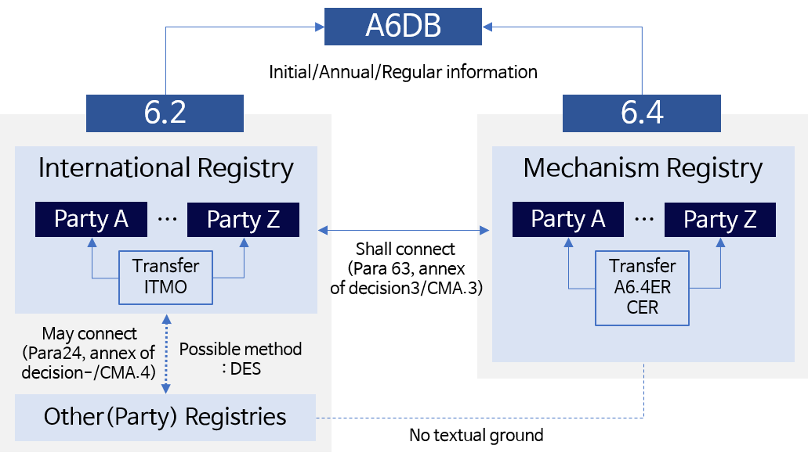
The ROK thinks that a key consideration regarding the interoperability between registries is that consistency of data and information should be ensured for the transparency of the Article 6 mechanism.

- Level of integration and transparency
While the A6.2 guidance spells out the minimal functions and level of integration of systems, the ROK proposes a system that would allow for the information exchange between Party’s registry or accounts within the international registry. The integrated registry system or connection of decentralized registries would enable, centrally record and track transfers as they move. It is possible either by linking registries, or mirroring information from individual registries in a centralized place (e.g. the A6DB). In this way, the A6DB could perform a role akin to a clearing house across individual registries, even if only indirectly. While the A6.2 guidance already provides for these consistency check functions related to the A6DB (para. 32(b) and 33), we suggest that this information be directly gathered from the individual registries if a Party wishes to do so. This would make possible more timely consistency check.
A more integrated infrastructure approach would allow for direct output of summarized transfer information as authorized by Parties to be available for reporting purposes. It not only bears significant potential for reducing transaction costs and manual reporting work. It could also improve the reliability and traceability of information over time and lead to enhanced transparency overall. We see the special potential for a more integrated approach between the international registry and the A6 Database since they all fall under the same unifying structure of the CARP. However, the same level of integration of information should also be rendered possible for Parties that use their own national registry.

- Synergies between Registries
Many countries have developed their own national registries, which are used for domestic and international purposes. These registries sometimes operate on different data standards and are not always interoperable. It remains the independent decision of all Parties to maintain, connect, or not connect their own national registries, depending on the technical complexity involved. As the guidance text notes, any Party may request an account in the international registry (para. 30) and could decide to use its existing national registry complementarily, should a direct integration not be desired.
The ROK believes that the Article 6 infrastructure will need to be able to include both information on A6.2 and A6.4. It should allow for the transparent exchange of information regarding the transfer of both types of units on the international level and into the national registries or accounts within the international registry. This is possible by either connecting national registries to the international registry since the international registry is linked to the mechanism registry, or making a linkage between the Art. 6.4 mechanism registry and Party registries if a Party wishes to do so to allow for the tracking and recording of the transfer, acquisition, and usage of A6.4ERs.

- Connecting method
As stated above, whether to connect the mechanism registry and the national registry, or the international registry and the Party registry is fully up to Parties. Yet, it is necessary to develop a method to link the mechanism registry and international registry, and Party registry and international registry if applicable. The ROK thinks that using unique identifiers and establishing a common data exchange standard (DES) could be one of the options that enable efficient connection between registries.
The 6.2 and 6.4 guidance already specify that each ITMO, and A6.4ER or CER tracked in the mechanism registry shall have a unique identifier as an identification method. The specific pieces of information comprising the unique identifier include at the minimum the identifier of the cooperative approach, the identifier of the originating Party registry, the identifier of the first transferring Party, the serial number, the vintage of the underlying mitigation outcome, as per decision -/CMA.4, annex I paragraph 5.
Under the Kyoto Protocol, the general design requirements for the technical standards for data exchange between registry systems were developed by the secretariat. Similarly, it would be helpful if the secretariat defines the minimum technical requirements and functions for data exchange between registries. However, Parties who wish to develop their own registries rather than using international registries are not obligated to apply all the features of DES as long as transparency for tracking and reporting is guaranteed.

- Host Party’s authorization – timing and relevant information
Pursuant to decision 3/CMA.3, annex, paragraph 42, the host Party shall provide a statement to the Supervisory Body whether it authorizes A6.4ERs issued for the activity for use towards achievement of NDCs and/or for other international mitigation purposes as defined in decision 2/CMA.3. However, it does not define the timing of the authorization and any relevant information to be included in the statement. The ROK would like to provide our views on the timing of the authorization and any relevant information to be included.

- Timing of the authorization by the host Party
A diagrammatic representation of the A6.4 activity cycle, as defined in the relevant paragraphs of decision 3/CMA.3, annex V, could be as shown in Figure 2 below. The authorization of A6.4ER indicates that a certain unit is used towards achievement of NDCs and/or other international mitigation purposes. Thus, the authorization of A6.4ER can take place only when and after the usage of A6.4ER is determined. Furthermore, considering that the usage of A6.4ER can be determined after a given activity is validated as an Article 6, paragraph 4, activity (hereinafter A6.4 activity) and that the activity is officially registered as an A6.4 activity after validation, the host party’s authorization could take place after validation.
Figure 2. A6.4 activity cycle
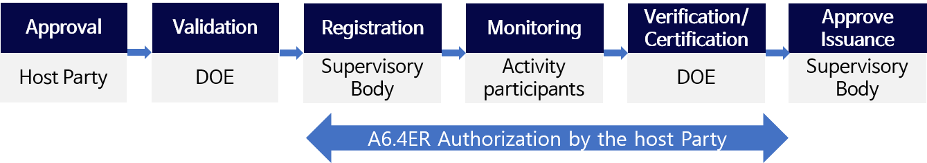
Also, according to decision-/CMA.4, annex I, paragraph 38, the mechanism registry administrator shall, at the time of the issuance of A6.4ERs, assign their authorization status in accordance with the statement by the host Party provided to the Supervisory Body pursuant to paragraph 42 of the RMPs. Hence, the host Party shall provide a statement about authorization to the Supervisory Body before the mechanism registry administrator assigns the authorization status at the time of the issuance of A6.4ERs. The authorization of A6.4ERs by the host Party could take place any time between after validation and before the issuance of A6.4ERs, as indicated in Figure 2 above.
The timing of authorization has implications for the level of flexibility in determining the usage of A6.4ERs from a given A6.4 activity. For example, if the host Party is to authorize the A6.4ERs from a given activity at its registration, the usage of all A6.4ERs generated throughout the life of the activity is confined to that particular usage. But if the host Party is to authorizes A6.4ERs any time between after registration and before issuance, the usage of the A6.4ERs from a given activity need not be limited to a particular purpose, be it achievement of NDCs or other international mitigation purpose; the host Party would be able to determine the usage of A6.4ERs as it sees fit. And at the time of registration the host Party won’t be in a position to know the full usage of all A6.4ERs from a given A6.4 activity. Therefore, it makes more practical sense to allow the authorization by the host Party of A6.4ERs to take place any time between after registration and before issuance.
- Relevant information on the authorization
For the information to be included in the authorization statement, the ROK thinks that it is desirable to submit such information based on Annual information referred to in decision2/CMA.3, annex, paragraph 20 to lessen the burden of the host Party. We suggest that the authorization statement include information on the host Party, registration number, activity participants, the sector(s) and activity type(s), crediting period, monitoring period, and the purpose of use as shown in Table 1 below.

Table 1. List of Information Items
Item | Description | Remarks
Host Party | Party that provides the statement to the SB
Registration number | Project registration number registered to the SB
Activity participants | The list of activity participants
Sector(s) and activity type(s) | Sector(s) and activity types(s) defined by the SB
Crediting period | The crediting period of the project | Renewal period if applicable
Monitoring period | Monitoring period for emission reduction | YY/MM/DD
Usage | Achievement of NDCs/Other international mitigation purposes (OIMP)

https://www4.unfccc.int/sites/SubmissionsStaging/Documents/202209261439---220920_ROK_s%20Submission%20on%20A6.2.docx

