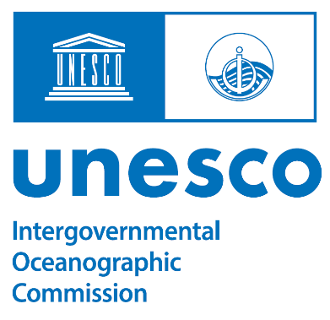
Opening statement for SBSTA
6 November 2022

Ocean science and sustainable ocean management are at the core mission of the Intergovernmental Oceanographic Commission of UNESCO, or IOC.
The ocean is at the heart of climate change, storing most of the excess heat and absorbing a major portion of the greenhouse gas emissions. In doing so, the ocean has slowed the temperature rise in the atmosphere, but its ability to continue to provide this invaluable service is in doubt. And in absorbing carbon dioxide, it has become less alkaline, with already visible and potentially devastating consequences of the ocean acidification for important ecosystems.
The ocean is at the heart of systematic monitoring of the climate system, and the IOC-led Global Ocean Observing System is an integral part of the Global Climate Observing System, and of its Implementation Plan which this body will consider. IOC fully supports the plan and stands ready to coordinate implementation of the actions that call on the IOC Member States.
The ocean can also be at the heart of climate solutions and sustainable development. This is why the IOC has been assigned by UN General Assembly to lead the United Nations Decade of Ocean Science for Sustainable Development 2021-2030. One major challenge of the Ocean Decade is to unlock ocean-based solutions to climate change, at the same time sustainably managing this important resource for all humanity. We invite you to join this effort, and to invest in ocean science for climate. Benefits from the new generation of solutions, for example climate-smart maritime spatial planning will be accruing in the ocean-climate nexus, conservation of biodiversity and sustainable ocean economy, reducing poverty.

