
Ref: MET/Vol/37-45

Sierra Leone Government
Meteorological Department, F18 Charlotte Street, Freetown, Sierra Leone

CONCEPT NOTE ON SUPPORT TO SIERRA LEONE PREPARATION OF NATIONALY APPROPRIATE MITIGATION ACTION

- BACKGROUND
Sierra Leone signed and ratified the United Nations Framework Convention on Climate Change (UNFCCC) in June 1995 and the Kyoto Protocol in April 2005 to meet its commitments to article 4 & 12 of the UNFCCC. Parties to the United Nations Framework Convention on Climate Change (UNFCCC) meet regularly to adopt new decisions. A decision was adopted in the Cancun Agreement in 2010 known as the Bali Action Plan (BAP) of 2007 (Para. 1 b). Just as Low-Carbon Development Strategies and Plans, NAMAs can be seen as concretizing Art. 4.1. b UNFCCC (commitment of all Parties to implement mitigation measures). However, the BAP remains vague on what actually constitutes a NAMA, the text giving no definition or further indications. In the years since, practical work has nevertheless led to a certain clarification of the notion, so that the following traits of NAMAs can tentatively be identified:
- Potentially all measures which contribute to the reduction or limitation of greenhouse gas emissions can be qualified as NAMAs.
- They contribute to the transformation of an economy towards low-carbon growth, combining development and climate change mitigation.
- NAMAs are carried out on a voluntary basis by both developed and developing countries.
- It is both possible to design and implement NAMAs unilaterally (“unilateral NAMAs”) or to rely on financial or technical support (“supported NAMAs”).
- The BAP specifies that the concept of NAMAs is closely linked to measuring, reporting and verification (MRV).
For climate change mitigation efforts to be successful, they must be reactive to national and local circumstances. In recognition of this correlation, the concept of Nationally Appropriate Mitigation Actions (NAMAs) emphasizes national ownership while responding to climate change under the unique conditions of each country.
  - JUSTIFICATION
NAMAs are an important tool for climate change mitigation since it gives policy-makers the opportunity to design mitigation measures in accordance with national circumstances and priorities as fleshed out in Low-Carbon Development Strategies and Plans (LCDS) or other relevant development plans. This enables states to avoid the lock-in of outdated, high-emission technologies and catalyses the transformation of the economy towards low-carbon and sustainable growth patterns. For developing countries, the planning of “supported NAMAs” can open up promising new opportunities for fast-track and long-term funding by public and private actors.

Recognizing the risks that climate change poses to communities and ecosystems around the world, the international community has adopted a goal under the UNFCCC to limit global warming to 2°C compared to preindustrial temperatures. While the IPCC’s Fifth Assessment Report (AR5) suggests that it is still possible to limit average global temperature rise to 2°C, it will require rapid reductions of emissions and changes to our current energy mix.

Also the Fifth Assessment Report (AR5) of the Intergovernmental Panel on Climate Change (IPCC) highlighted Sierra Leone as being amongst the highly vulnerable countries to the increasing frequency of climate change impacts. The country has been ranked as the third most vulnerable after Bangladesh and Guinea Bissau to impacts of climate change. We are increasingly experiencing the adverse effects of climate change related hazards in almost all sectors including agriculture, fisheries, tourism, forestry, water and infrastructure. These changes affect the lives and livelihoods of our rural communities in particular, which have the lowest capacity to adapt and depend on rain-fed agriculture and natural resource-based livelihoods. These extreme weather events can also severely disrupt a company’s operations, facilities, and logistics and supply chains.

On that note, Sierra Leone is soliciting both technical and financial support to undertake the preparation of the country Nationally Appropriate Mitigation Action (NAMA). The NAMA preparation and implementation process has the potential to strengthen national institutional capacity and transfer knowledge to sectoral institutions. As progress is tracked towards reducing our emissions over time, the capacity of technical staff will increase and a foundation will be built for tracking progress of our emission cut through different climate change interventions. Also developing the country NAMA can enable countries to link climate change to other national priorities, such as sustainable development and poverty reduction. It can also help countries coordinate among sectors and allow decision makers to identify synergies among sectoral plans for the overall reduction of their carbon foot prints over time without compromising development aspiration.

1.3 OBJECTIVE
To be able to prepare Sierra Leone nationally appropriate mitigation action (NAMA) that will reflect the country concerns in addressing the issues of climate change and build on sectoral synergies to enable emission reduction starting 2016.

1.4 SPECIFIC OBJECTIVE
- To mobilize financial resources to support activities in the preparation of the country nationally appropriate mitigation action (NAMA).
- To solicit technical support in facilitating the preparation of the country nationally appropriate mitigation action (NAMA).
- To support the development of a well articulated nationally appropriate mitigation action (NAMA).

1.5 EXPECTED OUTCOME
- Financial support provided to meet all relevant cost as budgeted.
- Country Technical team enhanced through external technical support.
- A detail road map known as the nationally appropriate mitigation action (NAMA) developed

1.6 WORK PLAN FOR THE DEVELOPMENT OF NATIONALLY APPROPRIATE MITIGATION ACTION (NAMA)
Country: Sierra Leone | Period | Dec 2015 to Apr 2016
Institution: Environmental Protection Agency- Sierra Leone (Climate Change Secretariat)
Activities/ Sub-Activities | Indicators |  |  |  |  |  | Responsible Institution (s) | Comments
Activities/ Sub-Activities | Indicators | Dec | Jan | Feb | Mar | Apr | Responsible Institution (s) | Comments
Phase 1: Setting the Stage (Preliminary Phase)
1) Source Funding to implement activities in the work programme. | Funding Sourced | X |  |  |  |  | EPA-SL(Climate Change Secretariat) | EPA-SL to engage donor agencies and other institutions to support the activities highlighted in the work programme.
2) Develop Terms of Reference for the recruitment of a consultant to undertake the exercise. | Term of Reference Developed | X |  |  |  |  | EPA-SL (Climate Change Secretariat) | Draft Terms of Reference to be shared with other stakeholders for input.
3) Hiring of Consultant | Consultant Hired | X |  |  |  |  | EPA-SL (Climate Change Secretariat) | Both national and external expert
4) Identification of NAMA team | NAMA team identified |  | X |  |  |  | EPA-SL/MTA/ SPU
5) Informal brainstorming meeting | Meeting held |  | X |  |  |  | EPA-SL/ MTA | Informal brainstorming meeting.
Phase 2: Analytical Work
1) Discuss and agree on preliminary steps of the processes for the development of national GHG emission contribution | Preliminary step finalised |  | X |  |  |  | NAMA Team | This includes the consultants and other stakeholders.
2) Data collection and analysis | Report available |  | X | X |  |  | NAMA Team
3) Technical exchange and cooperation on the review of analysis. | Meeting held |  | X | X |  |  | NAMA Team
5) Prepare option paper on strategic choices on emissions contributions. | Option paper available |  | X | X |  |  | NAMA Team
6) Peer review and validation | Peer review held |  |  | X |  |  | EPA-SL | EPA-SL to facilitate the process.
Phase 3: Consultations
Technical meeting to enhance support on the NAMA proposal | Meeting held |  |  |  | X |  | Technical team from various MDAs
Stakeholder meeting to enhance support on the NAMA proposal | Meeting held |  |  |  | X |  | Large National Actors
Political meeting to enhance support on the NAMA proposal | Meeting held |  |  |  | X |  | District and National political actors
National Event to support "high-level disclosure" and "reality check meeting" | Meeting held |  |  |  |  | X | National Media, International institutions and political audience

1.7 BUDGET
Table 1: Summary of Budget
COMPONENTS | Donor contribution (US$) | Government Contribution  (in kind) | Total Budget  (US$ ’000)
1.SETTING THE STAGE
National Expert (Lump Sum) | 10,000
International Expert (Lump Sum) | 40,000
Brainstorming Meeting | 10,000
Sub Total |  |  | 60,000
2.ANALYTICAL WORK
Preliminary Steps | 10,000
Data Collection & Analysis | 20,000
Review Analysis | 10,000
Sub Total |  |  | 40,000
3.CONSULTATIONS
Technical Meeting | 10,000
Stakeholder Meeting | 10,000
Political Meeting | 10,000
National Event | 20,000
Sub Total |  |  | 50,000
GRAND TOTAL (USD) |  |  | 150,000
Faithfully Submitted By:

Alpha Bockari
Director/UNFCCC National Focal Point for Sierra Leone
Meteorological Department
Alpha_bock@yahoo.com
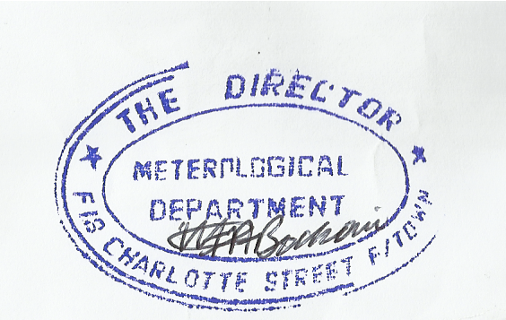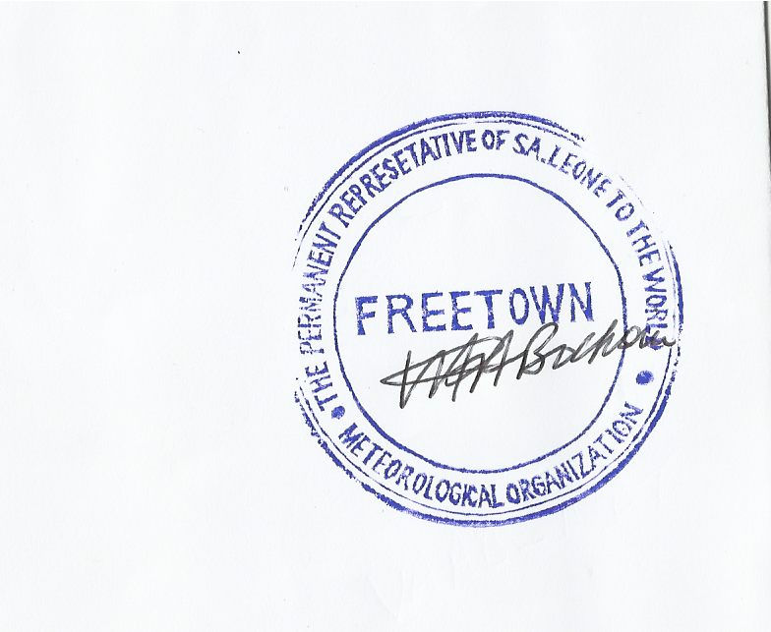
Alpha Bockari
Director

