NAMA Seeking Support for Implementation

University of Banja Luka
Faculty of Architecture, Civil Engineering and Geodesy
Republic of Srpska
Bosnia and Herzegovina

NAMA PROJECT:
SUSTAINABLE AND ENERGY EFFICIENT BUILDING
OF FACULTY OF ARCHITECTURE, CIVIL ENGINEERING AND GEODESY

Banja Luka, June 2015.

Project Manager: | Raduška Cupač | UNDP B&H
Authors: | Milenko Stanković | University of Banja Luka, Faculty of Architecture, Civil Engineering and Geodesy
 | Nevena Novaković | University of Banja Luka, Faculty of Architecture, Civil Engineering and Geodesy
 | Saša Čvoro | University of Banja Luka, Faculty of Architecture, Civil Engineering and Geodesy

CONTENT

INTRODUCTION _4
- BRIEF CONTEX OF CLIMATE CHANGE IN BANJA LUKA AND BOSNIA AND HERZEGOVINA_4
- PROBLEM OF ENERGY EFFICIENCY OF BUILDINGS AND POTENTIAL FOR MITIGATION ACTIONS _6
- VISION ABOUT SUSTAINABLE AND ENERGY EFFICIENT BUILDING OF FACULTY OF ARCHITECTURE, CIVIL ENGINEERING AND GEODESY IN BANJA LUKA_8
- ARCHITECTURAL CHARACTERISTICS OF THE BUILDING_10
- ENERGY EFFICIENCY PRINCIPLES AND GHG REDUCTION_12
- PLANNED ACTIVITIES AND COMPONENTS_19
- PROJECT ACTORS_21
- FINANCING STRUCTURE OF THE NAMA PROJECT_22

INTRODUCTION
The University of Banja Luka (UBL), established in 1975, is the second largest in Bosnia and Herzegovina, with more than 17 000 students. It consists of 16 faculties: Academy of Arts, Architecture, Civil Engineering and Geodesy, Economics, Electrical Engineering, Mechanical Engineering, Medicine, Agriculture, Law, Natural Sciences and Mathematics, Technology, Sport, Philosophy, Philology, Forestry, Political Sciences, and Mine Engineering. UBL has 56 licensed study programs at the first cycle and is fully committed to the idea of a borderless area for research and knowledge exchange in Europe. Besides of an excellent location and own facilities, UBL has other competitive capabilities, including about 1 100 research active staff for teaching and research excellence. UBL, with 100 bilateral agreements with public and private universities worldwide, has been involved in more than 85 Tempus projects, several FP6 and FP7 projects, as well as a number of other international projects funded by the European Commission, Council of Europe, UN, UNESCO, the World Bank and other international organizations and foundations.
The Faculty of Architecture, Civil Engineering and Geodesy (FACEG), established in 1995, performs educational and research activities. It consists of three departments: Architecture, Civil Engineering and Geodesy. There are around 1200 students involved in the study programs. The Faculty is committed to the policy of intensive development and integration into the European integration process. This is primarily related to the improvement of the educational , scientific and research process, solving the problem of insufficient and inadequate space, the acquisition of modern research equipment, and advancement of intensive cooperation with other related faculties, as well as the economic institutions of various kinds.
Currently, faculty has on its disposal two buildings with 1700 m² of available space in total at two locations. Spatial capacities, where classes and research are conducted, are insufficient and inadequate in terms of working comfort, especially the thermal and air conditions. In 2008, The Faculty of Architecture, Civil Engineering and Geodesy and the University of Banja Luka launched an initiative for the preparation of investment and technical documentation for the construction of a new building of FACEG. The analysis of the spatial requirements for teaching and scientific research process defined an initiative programme framework for the design of facilities, which includes the application of the energy efficiency principle, specific standards and intelligent systems as significant standards of optimisation in the contemporary architecture (EU standards). The internal architectural competition for the preliminary design of the building was organised and the proposal of Saša B. Čvoro and Malina Čvoro was chosen. Construction of the building began in 2012.

BRIEF CONTEX OF CLIMATE CHANGE IN BANJA LUKA AND BOSNIA AND HERZEGOVINA
The wider area of Banja Luka is characterised by a moderate continental climate, although there is a relatively short distance from the Adriatic Sea. The moderate continental climate type of Banja Luka has elements of Pannonian or prairie climate impact, due to the proximity of the Pannonian Plain. The main characteristics of this type of climate are warm summers and cold winters. Summer temperatures can rise up to 40°C, and the absolute maximum of 43°C in the Republic of Srpska was measured in 2007 in Bijeljina and Višegrad. The average air temperature in the warmest part of the year (in July) is between 20°C and 23°C, while the average temperature in the coldest part of the year (in January) is around 0°C. The absolute minimums can reach up to -30°C. The average annual temperature is 10,7°C, average temperature in January is -0,8°C, while the average temperature in July is 21,3°C. The average annual cloudiness is 62%, while the average annual relative humidity is 77%. The most frequent winds are from the northern quadrant, and the greater part of the year in Banja Luka is calm.
According to the available historical climate data, which show that the rise in air temperature in the 20th century was recorded in the Republic of Srpska and Bosnia and Herzegovina is similar to the trend registered in other parts of Southeastern Europe. Although the influence of local factors makes the differences in the rate of temperature change, generally, there are two specific areas: mountain areas above 1500 m above sea level with a temperature increase of 0,8 to 1,0°C and lower regions, which include the territory of Banja Luka, with an increase in temperature of 0,6 to 0,8°C.
Apart from the temperature changes, there were changes in terms of precipitation. During the 20th century a tendency of increase in precipitation was registered in Northern Europe, while in Southern Europe, a decrease in precipitation by 13% on average was recorded. The quantity of rainfall is affected by humid air mass coming from the west (the Atlantic) and the south (the Mediterranean). Precipitation is the most variable climatic parameter in terms of space and time. In the area of moderate continental climate the highest rainfall occurs in the warm part of the year, and maximum occurs in June. Rainfall ranges from about 750 l/m² per year in the north along the Sava River up to 1500 l/m² in the west of Krajina.
Comparing the spatial distribution of air temperature in the city of Banja Luka in standard reference climate periods (1931 - 1960 and 1961 - 1990) with the estimated values of temperature for the period from 1991 to 2030 reveals that in the period from 1931 to 1961 the largest part of the city area was in the temperature range between 10°C and 11°C, in the period from 1961 to 1990 in a temperature range between 10°C and 12°C, and estimated temperature for the period from 1991 to 2030 is between 12°C and 14°C. During the last thirty years summers have become drier and quite warm with average air temperature of about 20,1°C, while in the period from 1951 to 1980, the average summer temperature of air in Banja Luka was 19,6°C.
Statistical analyses show that during the last 10 years of the last century in the area of Banja Luka historical absolute maximums of air temperature were surpassed for January, February, April, June, July, November and December, while in terms of absolute minimum of air temperature only historical absolute maximum value for the month of October was exceeded. The decade change of the average annual air temperature in the area concerned is positive and ranges from 0,1 to 1,5°C. By 2030 registered temperature warming from the last decade of the twentieth century would be tripled.
According to Hydrometeorological Institute of Republic of Srpska, the average annual air temperature in the city of Banja Luka in the period from 1981 to 2000 was 11,1°C, while in the period from 2001 until 2010 the average temperature was 11,9°C. These data suggest that in Banja Luka, comparing the two periods, average temperature has increased by an average of 0,8°C.
Analysis of monthly data of the two measurement periods shows that the largest average increase in air temperature by 1,6°C occurs in the second part of the spring, and in the summer it is in July, when the temperature is higher by 1,8°C. In the winter months, the biggest change of temperature is in January with an increase of 1,4°C. The data also show that in the period from 2001 to 2010 an absolute minimum of -23,5°C in Banja Luka was recorded in January 2003, and that there was also an absolute maximum of 41,4°C in July 2007.
Climate changes that have been recorded in the city of Banja Luka, especially from the second half of the 20th century onwards, have been recognised in the geographical area of the entire country in the contents of The Initial National Communication (INC) and The Second National Communication on Climate Change (SNC). Their main characteristics are the increase in air temperature combined with the change in the precipitation regime, as well as increased climate variability during all seasons and throughout Bosnia and Herzegovina. On the basis of climatological forecast models, in Bosnia and Herzegovina, the air temperature is expected to increase in the period from 2001 to 2030 by + 0,8°C to 1,0°C above the average temperature, while in the period from 2031-2060 the increase will be by +2,0°C to + 3,0°C in the inner part of the country.

PROBLEM OF ENERGY EFFICIENCY OF BUILDINGS AND POTENTIAL FOR MITIGATION ACTIONS
Аccording to data from the Draft of National Energy Efficiency Action Plan (NEEAP) from 2012, buildings are responsible for the highest share of end consumption of energy in Bosnia and Herzegovina. Approximately this share is 60% at the national level, but in some cities and municipalities it goes above 80%. So, buildings are responsible for a major share of greenhouse gas emissions directly and indirectly through electricity consumption.
According to The Sustainable Energy Action Plan of the City of Banja Luka (SEAP) from 2010 the total energy consumption in the city of Banja Luka was 1457 944,38 MWh in 1990, which corresponds to the total emission of CO₂ of 664 322,94 t. Most of the energy is consumed in the building sector, and about 90% of CO₂ is emitted by this sector, while the traffic accounts for 10% of total emission.
80 to 90% of the energy consumed in the phase of construction fund exploitation is used to meet the basic comfort conditions of working environment such as heating, cooling, ventilation, hot water and lighting. The increase in living standards and variety of modes of functional organisation and space materialisation in accordance with the needs of everyday life, significantly affect the constant in crease in energy consumption.
The above-mentioned data show that the construction fund has a large potential for energy and environmental savings, and that the examination of energy optimisation of buildings is one of the primary and long-term goals at the global and, at the same time, at the local level. Applied materials, building systems and architectural structures, method of construction and life expectancy of buildings have resulted in large, long-lasting and continuous influence on the overall energy consumption and our environment. Applying the appropriate norms and standards in the design of new and reconstruction of existing facilities helped to set up mechanisms for possible savings of over 25% of current energy consumption in civil engineering, in the construction and exploitation phase. By 2025, carbon dioxide emission will be reduced by applying the EU mechanisms of energy efficiency in building for 0,55 Mt of CO₂eq emission per year. If the heating of residential buildings by burning fossil fuels was replaced by burning biomass, potential for climate change mitigation in building would be 4,2 Mt of CO₂ eq in total.
In order to generally reduce energy consumption and preserve the environment, one of the primary and long-term priorities is the research and application of energy optimisation and rationalisation in civil engineering. An important overarching document at the level of Bosnia and Herzegovina, which defines construction industry as one of the key sectors with the potential for climate change mitigation is Strategy for Climate Change Adaptation and Low-emission Development for Bosnia and Herzegovina, which was adapted by the Council of Ministers of Bosnia and Herzegovina on 8th October, 2013. According to this document, investment into energy efficiency improvement, renewable energy resources, and district heating systems will have a positive social and economic impact even without consideration of the impact on greenhouse gas emission reduction. Emission reduction in the building sector should therefore be considered as a key priority (p. 36).
Directive on the Energy Performance of Buildings in EU (Energy Performance of Buildings Directive - Directive 2002/91 / EC, EPBD) is a key document when it comes to energy efficiency in buildings, which is a driving force in the area of ​​legislative changes in the countries of the region. Directive was first published in 2002, which required all EU countries to enhance their building regulations and to introduce energy certification schemes for buildings. In order to adapt legislation in the field of energy efficiency of buildings to the standards of the European Union, in 2010, the Republic of Srpska adopted a strategy document Energy Development Strategy of the Republic of Srpska until (and including) 2030, which is based on energy policy and legislation of the European Union.
In June 2013, The Law on Energy Efficiency was adopted (Official Gazette of the Republic of Srpska, no. 59/13) and aims at "reducing the negative impact on the environment, increasing security of energy supply, meeting the energy needs of all consumers, reducing emission of CO₂ and greenhouse effect gases, encouraging responsible behaviour towards energy, rationalising energy consumption, eliminating energy poverty and fulfilling obligations under international treaties, agreements and conventions." Another document that is directly related to civil engineering and architecture, The Law on Spatial Planning and Construction (Official Gazette of the Republic of Srpska, no. 40/13), defined the adoption of the Ordinance on the minimum requirements for the energy performance of buildings, the Ordinance on the energy audits of buildings and the Ordinance on the methodology for calculating the energy performance of buildings (Article 93). By the time of the implementation of these ordinances in the field of energy efficiency of buildings, in the Republic of Srpska JUS standards are still in use:
- JUS standard U.J.5.600 for the technical requirements for the building thermal technique that must be met in the design, construction and reconstruction of buildings,
- JUS standard U.J.5.510 for calculation methods for the coefficient of heat transfer in buildings,
- JUS standard U.J.5.520 for calculation of water vapour diffusion,
- JUS standard U.J.5.530 for calculating the damping factor and the delay of temperature oscillations through the exterior building partitions in the summer.

By signing the Covenant of Mayors in 2009, Banja Luka is committed to prepare a Sustainable Energy Action Plan of the City of Banja Luka (SEAP) within one year after signing. This Action Plan shows that the local authorities are going to achieve a reduction in CO₂ emission by 20% until 2020. Considering that the agreement covers the entire area of ​​the City, Sustainable Energy Action Plan includes activities related to both the private and public sector. Activities are divided by sectors and subsectors. In the building sector, special attention is paid to the activities of the reduction of heat losses. Therefore, the Action Plan, in accordance with European measures, requires a minimum standard to be applied to the design and construction of small buildings, then larger buildings and buildings that are being renovated. A special segment is the inclusion of "passive buildings".
Based on the above-mentioned, NAMA project of sustainable and energy efficient building of FACEG, which is in accordance with the following national and local documents and in whose context it represents appropriate measures for climate change mitigation in the sector for energy efficiency in building:
- Strategy for Climate Change Adaptation and Low-emission Development for Bosnia and Herzegovina (2014),
- Draft of the National Action Plan for Energy Efficiency (NEEAP, 2012),
- Energy Development Strategy of the Republic of Srpska (2010),
- Law on Energy Efficiency (2013),
- Law on Spatial Planning and Construction (2013),
- Strategy for Development of Banja Luka in the period from 2007-2015 (revised in 2012),
- Sustainable Energy Action Plan of the City of Banja Luka (SEAP, 2009).

VISION ABOUT SUSTAINABLE AND ENERGY EFFICIENT BUILDING OF FACULTY OF ARCHITECTURE, CIVIL ENGINEERING AND GEODESY IN BANJA LUKA
The FACEG facility is designed as a laboratory of knowledge whose spatial capacities are built in accordance with the highest ecological and social standards, which would provide the improvement of teaching and scientific research process towards educational standards of Europe and the developed part of the world. The role of architecture and civil engineering in this project is extended to meet society needs for environmental protection and education of both individuals and society in the ecologically responsible manner, in relation to its common role of meeting spatial, functional and aesthetic requirements. New building of FACEG would be unique and intended to be used for the education of Engineers of Architecture, Civil Engineering and Geodesy in the region, and quite possibly in Europe, on the basis of the application of low and passive energy standards in design. The school philosophy is aimed at educating responsible experts who are ready for critical thinking, team work and the temptation of the moment of the social development. The structure of its new building is conceived as one of the elementary instruments of operationalising the vision of education of socially and environmentally responsible individuals.
The main objective of the project is to reduce GHG emissions from building sector and at the same time set a prototypical example for solving the problem of spatial and technological capacity for teaching and scientific research by designing and construction of environmentally friendly and energy efficient building of FACEG. The goal is to establish sustainable instrument for managing energy of the building which will result in reduction of CO₂ emission for over 50% in relation to the CO₂ emission of buildings of educational purpose with the typical spatial configuration and materialisation in Banja Luka. Also, the goal is to classify the new building in the category of passive 0+ buildings, i.e. to the category of buildings enabled to generate the energy required for their operation. The new building of FACEG is designed as an examplar facility in the context of education about energy efficiency and sustainability in building.
The proposed project components, each aligned with the above strategic documents and goals, are to secure:
- Climate change mitigation by reducing CO₂ emission for over 50% in relation to the CO₂ emission of buildings of educational purpose with the typical spatial configuration and materialisation in Banja Luka by applying the low and passive energy standard for design and construction of buildings;
- Improvement of the quality of the environment by reducing the water pollution, by contributing to the maintenance and preservation of green structure and the introduction of new one in the close vicinity of the facility;
- Improvement of the quality of the environment by using renewable energy resources such as water and sun for heating and cooling air in building as well as for heating sanitary water;
- Initiation of the conceptualization and realization of a larger project of regeneration of the University campus and the waterside, according to BlueGreenDream principles, as a measure to adaptation to climate change in urban systems by exploiting the synergies of water and green structures. FACEG building would be defined as the focal point of the project;
- Investment return through energy-consumption savings;
- Long-term effect on knowledge transfer and new technologies by applying the principles and installation of systems for energy efficiency in buildings that have been recently developed in EU and which would be available to the students of architecture and civil engineering for on-the-spot learning;
- Increase of citizens' awareness of their responsibilities towards the environmental protection and sustainable use of energy by applying energy efficiency measures in building educational facilities. Promotional program and material about the building would be developed and disseminated;
- Increase of job positions that would be opened by the increasing spatial capacity and the need for maintaining technological systems of the building;
- Significant improvement of spatial and technological capacity for teaching and scientific research at FACEG and University of Banja Luka;
- Compliance with the sustainable and low-emission development that is defined by the state and local strategies and plans mentioned above.

ARCHITECTURAL CHARACTERISTICS OF THE BUILDING
The site for building the new FACEG facility is situated within the comlex of former military barracks “Vrbas“, i.e. within new University town in Banja Luka. The University town is located in the eastern part of the city of Banja Luka, in the close vicinity of the Vrbas River, and occupies the area of 26,68 ha. The site, which is now a protected area for resource management in order to preserve dendroflora and ornithofauna and objects of cultural and historical heritage, got its first architectural countours as a military complex in Austro-Hungarian Empire at the end of 19th century.
On the site intended for the FACEG, which is located within the University town, there is a facility called “Tereza“, which has been out of service and belongs to the type of administrative buildings of that time. It was built in 1889. The building, which has been out of use for a long period of time, before the reconstruction works was in a very bad state with the damages to the exterior walls and the occurence of moisture. Exterior openings required complete replacement, and floor, mezzanine and roof structures were carried out without layers of thermal protection.
The inherited site of military barracks which is managed by the University consists of an area rich in park structures, grass areas and protected dendro fund. From the urban aspect, the University town is a heterogeneous group of objects of different periods of building, architectural design and materialisation. In that sense, the main task in the process of constructing a new building of the Faculty, i.e. reconstruction, extension and refurbishment of “Tereza“, is to set contemporary architectural values on the inherited site. This includes the establishment of a new element in the morphological structure of the University town, in accordance with the spatial context and future needs of the building, with the dominance of the current natural fund.
Designed FACEG building consists of GF + 3 floors of the existing extended building, and B + GF +3 in the new annex of the building. The main architectural and urban parameters such as spatial organisation, horizontal and vertical dimensions, ways to access the building and elements of design and materialisation, are defined in accordance with the current spatial planning documents - Regulation Plan "Student Centre". Architectural development was further conditioned by spatial and functional needs, real possibilities on the site, position of adjacent buildings, location of existing and planned traffic communications and green areas, and the needs of organisation and materialisation of the object in order to be energy efficient.
New space capacity is defined upon the current and planned number of students, and the type of teaching that is conducted at the three departments. In the functional and design sense, innovative remodelling of the existing object is planned, which contributes to the visual identity of the University town. The structure of the object makes an impression of extension and refurbishment, undoubtedly separating old and new parts. The building with the traditional stylish elements matches the modern, new, extended part of the building.
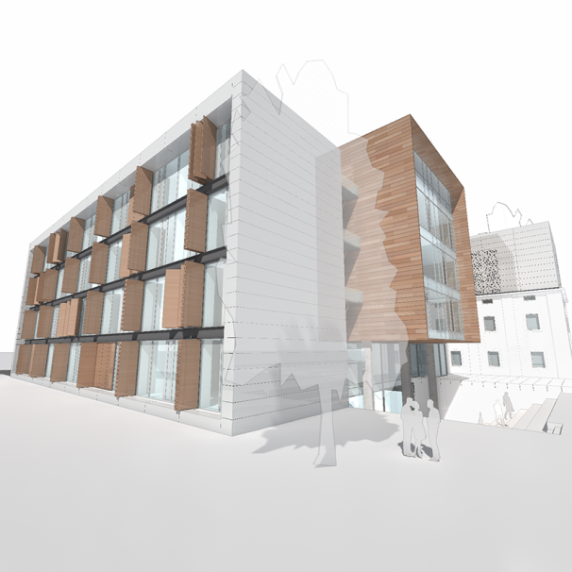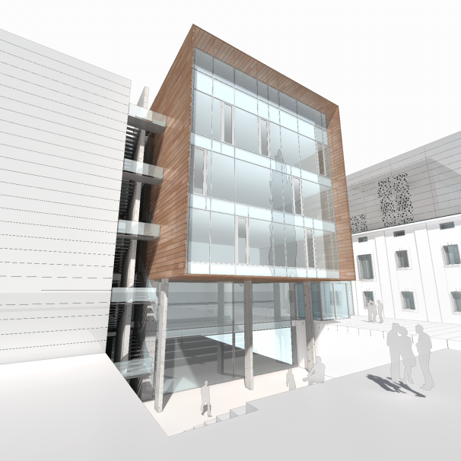
Picture 1. Planned appearance of the FACEG building.

Basic principles for elaboration of architectural design and preparation of project documentation were:
- to make a plan of new facility as an element of urban form,
- to make the building comprehensible and approachable to users,
- to achieve a cultural contribution to the atmosphere of the educational area,
- to reduce necessary financial resources,
- to tend toward energy efficiency and sustainability.

Table 1: Basic spatial dimensions of the FACEG building
Total area | 7.261,12 m²
Area | 6.810,70 m²
Total volume | 24.440,15 m³
Volume | 19.980,50 m³
Floor area | Basement 1.049,50 m²  Ground floor 2.005,07 m²  1st floor 1.316,37 m²  2nd floor 1.657,21 m²  3rd floor 1.232,97 m²
Height of the room | Basement 3,72 m  Ground floor3,72 m  1st floor 3,72 m  2nd floor 3,72 m  3rd floor 3,72 m

The process of preparation of investment and technical documentation is completed with The Main Project and Study on Energy Efficiency, both of which define all the elements of functional organisation, materialisation and shaping of the designed building, confirm achieved standards for passive buildings, and create conditions for issuance of Construction permits.
Based on the Memorandum of the project "Rehabilitation of the building for the purposes of the Faculty of Architecture and Civil Engineering in Banja Luka", from 2011, the economic-social component of the Development Programme of the Republic of Srpska assigned the necessary resources for preparation and start of the construction of the Faculty building. Taking into account the estimated value of the building, it was found that the allocated funds would be sufficient for preparing of the part of the investment and technical documentation, obtaining permits for building and carrying out of the first phase of work. The first phase of construction involves performing a part of major construction works, i.e. the construction of the base of the structural system, without the final construction of the outer layer, flat roof, interior works, installation systems and installation of appliances and equipment. Construction of the building began in 2012 and the first phase of work is completed.

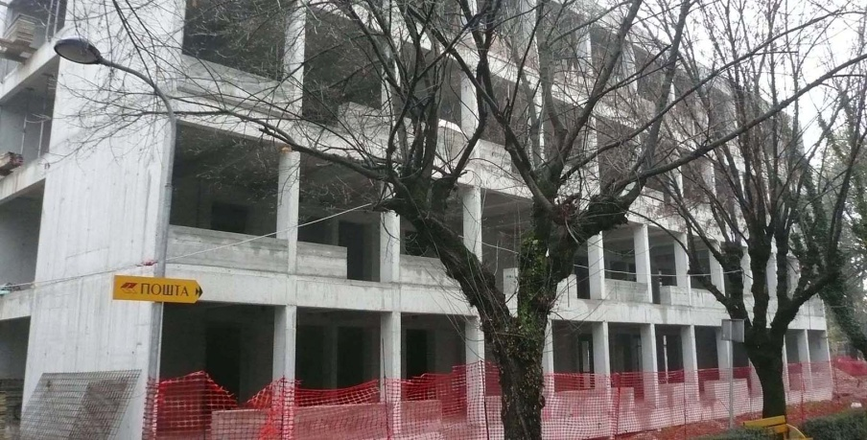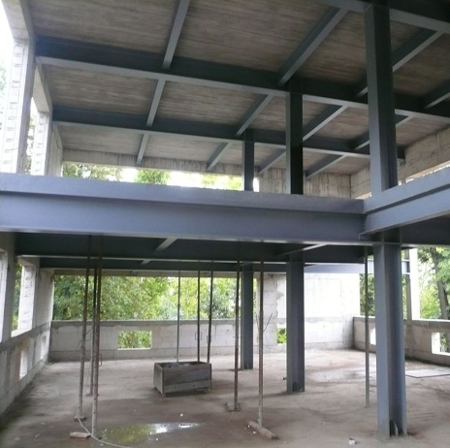
Picture 2. Current state of the FACEG building

ENERGY EFFICIENCY PRINCIPLES AND GHG REDUCTION
The scope and character of energy efficiency is determined by the estimated future energy performance of the building, which determines maximum power consumption for heating (and cooling the facility) by the amount of up to 15 kWh/m² per year, primary energy consumption to 120 kWh/m² per year, and the air tightness of the outer layer is n50 ≤ 0,6 h⁻¹.
The main source of heat in the building are the heat pumps that operate by water – water system. Analysis of the well waterabundance on the facility site, made in early 2012, indicated the individual capacity of a water source with about 3,5 l/s, the minimum temperature of well water in winter of 12°C, while in the summer the maximum temperature is 15°C. The total value obtained in four wells explored fully meet the total demand for energy needed for heating and ventilation of the future building which is 9,0 l/s.
All the rooms that are heated are connected to the central system for insertion of the fresh and removal of contaminated air with the return of heat. In order to optimise energy consumption and rationalise the entire investment, the required energy standards are arranged in the building on certain functional and spatial units. Thus, the spaces in the old and the new part of the building are determined by the passive standard, and the central internal communication between these two parts is defined by low-energy standard.

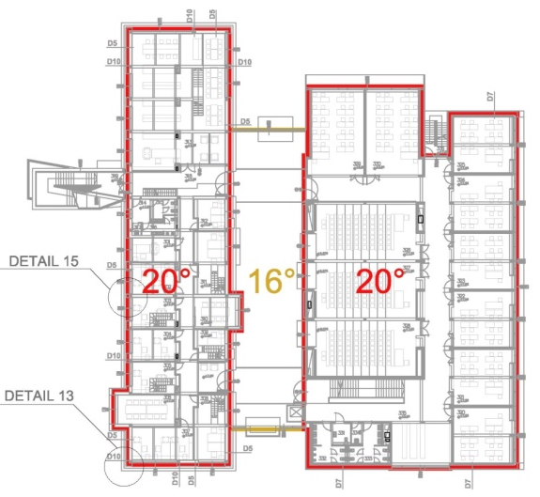
Picture 3. Graphic distribution of estimated air temperature in the building (right - second floor and left – section)

In the rooms with the air capacity per person than 100 m³/h air quality sensors are planned in terms of the amount of CO₂, while in the rooms with the air capacity per person than 100 m³/h, there are sensors for the presence. These devices automatically regulate opening of the external hole which is managed by the integral central system and electronic data processing. These devices can perform automatic opening of external frames, which is managed through the integrated central system of electronic management and data processing.
Outer frames with thermal break and a three-layer low-emission glass are determined by necessary heat transfer coefficient, U - value of 0,8 to 1.1 W/m²K, and the necessary coefficients of air tightness of the class 1 according to EN 12207/2001. In accordance with the principles of installation recommended by The Passive House Institute in Vienna, frames are installed in the level of thermal insulation with insulation flap over the outside of the window frame as much as possible. Air tightness around the frames, for the required energy performance, is achieved by applying the sealing profiles made of ethylene propylene diene rubber in various forms.
As a form of energy optimisation natural ventilation has been designed in the following forms:
- Transverse night ventilation with maximum utilization of the thermal mass cooling in the summer, combined with automatic operation of opening windows;
- Buoyancy driven natural ventilation through the glazed roof extensions in the old part of the building;
- Buoyancy driven natural ventilation of the glazed central hall with maximum utilization of the direction and intensity of dominant local winds (the effect of the inner courtyard);
- Dual-layer, segmented facade is applied to the façade base of upgraded floors as protection from solar radiation and wind gusts, and allows natural ventilation and cooling on the upper floors with a large glazed areas. The facade base, unlike conventional double-skinned facades, designed with perforated ceramic plates and the inner facade membrane with wings for controlled insertion and ejection of air.

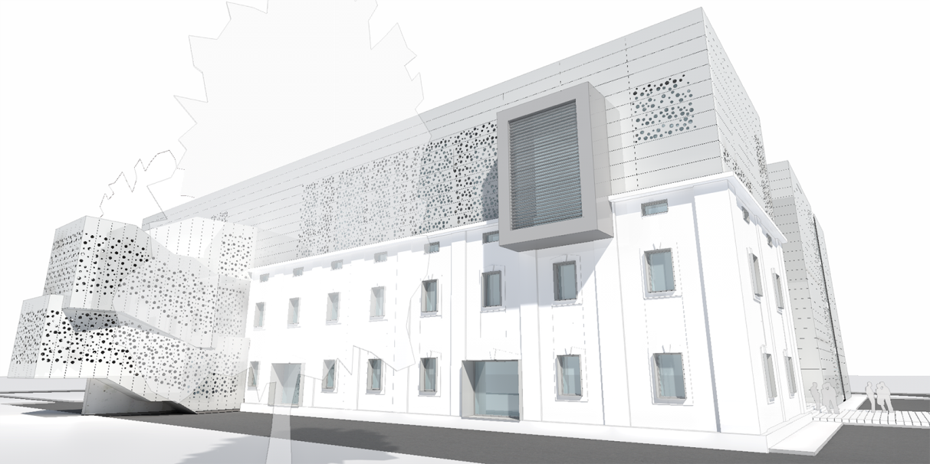
Picture 4. Three-dimensional view of the old building with the implemented dual-layer, segmented façade

Sanitary hot water is provided by renewable energy resources and using thermal energy from groundwater sources (wells) in the interim and winter season, and solar collectors throughout the year that are on the flat part of the impassable roof of the new building. As the building is not a significant consumer of sanitary hot water due to its specific purpose, for calculated required volume of 1.000 l five solar board panels are designed with the central solar water heater and control integrated into the central system of electronic management and data processing.
In order to achieve rational consumption management of sanitary and technical water provided for the construction of systems and equipment for the collection and use of atmospheric, ground and sanitary waste water, their storage and recycling (BlueGreenDream principles). Collected and treated waste water is used to maintain the existing plant population within the protected complex of the University town, and the planned plant population on green flat roofs of the new building. Also, the recycled technical water is used as technical water for the operation of the facility (sanitary cistern flushing, cleaning and building maintenance, etc.).
As a part of the sustainability concept and maximum utilisation оf energy out of the renewable sources, it is forseen to install transparent photovoltaic panels on the remaining central hall which is located between the two parts of the object. Electricity generated in this way allows the minimum consumption of electricity in public power system of the Republic of Srpska. In order to rationalise the consumption of electricity in the building, project documentation provides the application of energy saving light sources with optimised number and position of lamps, VAV control, all within an integrated central system of electronic management and data processing in the building. Considering these measures the newly designed building belongs to the category of passive buildings 0+, i.e. buildings that are able to produce as much energy as it is required for their operating.

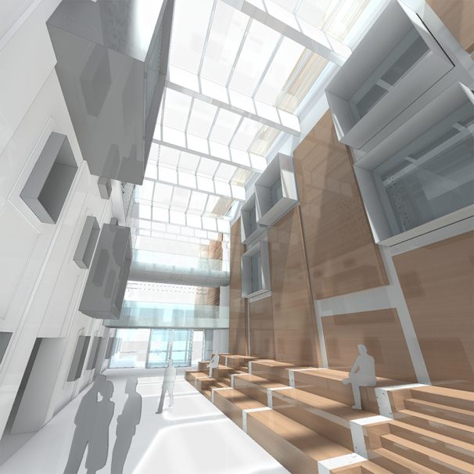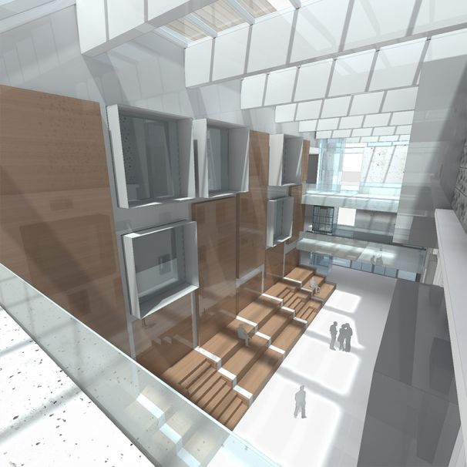
Picture 5. Three-dimensional view of the glazed central hall with photovoltaic panels on the roof that is oriented to the south

The values ​​of estimated consumption of energy used for heating the building is 8,1 kWh/m² per year and the total energy consumption of 14,8 kWh/m² per year, classifies the FACEG building in energy efficiency class A +. The final consumption of electricity in the AGGF building is supposed to be 107.463 kWh/per year.

Table 2. An overview of energy consumption per item
Balance/final energy | Estimated (kWh/m² a)
Heating | 8,1
Ventilation | 2,6
Hot water | 0,9
Lighting | 2,9
Other items | 0,3
Cooling | -
TOTAL | 14,8

For the calculation of primary electricity consumption and CO₂ emission in newly designed building indicators in accordance with standard EN 15603, Annex E were taken into account. For electricity generated from hydropower, coefficient for primary energy (fp) is 0,50 and the specific CO₂ emission (K) is 7 kg/MWh, and the electrical energy generated from the coal coefficient for primary energy (fp) is 4,05, and for specific CO₂ emission (K) coefficient is 1340 kg/MWh. Estimated production of electricity in the Republic of Srpska according to these indicators has a coefficient of primary energy of 2,45 and specific CO₂ emission of 740,15 kg/MWh. According to the Energy Balance of the Republic of Srpska - plan for 2014, 45% of electricity production in the Republic of Srpska is based on hydroelectric power and 55% on thermal power (coal).
According to these parameters consumption of primary electrical energy in the newly designed FACEG building is 36 kWh/m² per year, and CO₂ emission for electrical energy is 11 kg/m² per year. As the building does not use heating energy whose primary source is fuel oil, which is used for the production of heating energy in the system of heating plant in Banja Luka, the total primary energy consumption is 36 kWh/m² per year and CO2 emission is 11 kg/m², or 74,6 tons per year.
Table 3. Energy consumption balance
Indicators | Energy carrier
 | Heating energy | Electrical energy
Final energy (kWh/m²a) | - | 14,80
Primary energy (kWh/m²a) | - | 36,00
CO₂ emission (kg/m²a ) | - | 11,00
Total emission CO₂ (t/y) | - | 74,60
Total emission CO₂ (mtCO₂e) | - | 67,70

The amount of material investments in reconstruction, adaptation, expansion and refurbishment of the existing facility "Teresa" according to defined architectural characteristics and energy performance is determined on the basis of the average market value of construction works during 2013. Total investment in the construction of the newly designed building amounts to 15.091.874,35 BAM (7.716.352,00 €), and the average value of investment in construction to 2.147,39 BAM/m² (1 098 €/m²).
Economic efficiency of established measures for ensuring the air comfort and the defined energy performance of the building is defined by the time of repayment of necessary additional investment in the construction work. This material investment is defined according to the difference between the defined value ​​of the building construction and the value of construction work for the equivalent building with standard energy performance and it amounts to cca 2.700.000,00 BAM. Also, account is taken of the necessary final energy used for heating the equivalent building with standard energy performance and is cca 1.100.000 kWh/per year. Official data on the cost of delivered heat and electricity in the area of ​​Banja Luka are used to determine the economic efficiency. Considering all of these parameters it is determined that the time of repayment of the established measures for providing an air comfort and defined energy performance of the building is 17,45 years. The total calculated energetic, environmental and economic indicators of the designed reconstruction, adaptation, refurbishment and extension of existing building "Teresa" for the purposes of FACEG, are presented in table 4.

Table 4. Energetic, environmental and economic indicators
Final energy consumption | 14,8 kWh/m² a
Primary energy consumption (kWh/m2 a) | 36
CO₂ emission (kg/m²a) | 11
Total CO₂emission (t/per year) | 74,6
Total emission CO2 (MtCO2e) | 67,7
Total investment value | 15.091.874,35 BAM (7.716.352,00 €)
Average investment value | 2.147,39 BAM/m² (1.098,00 €/m²)
Repayment period of defined measures | 17,45 years

The evaluation of results and justification of the implementation of energy efficiency measures and the use of renewable energy is influenced by primarily energetic, economic and environmental analysis conducted on representative samples of existing buildings in the University town. In this sense, apart from the building of FACEG, the Rectorate building and the building of Faculty of Philology were chosen for comparative analysis of the results of the application of energy efficiency measures. For the comparative analysis, these buildings, that are characterised by significant differences in terms of timing, methods of construction and energy performance that they have, have been selected in order to investigate the possibility of applying different options and combinations of measures.

Table 5. Comparative analysis of general, energetic and ecological parameters of the representative samples of the research according to the current state and after applying measures for air comfort improvement
Parameters | Rectorate building |  |  | Philological Faculty building |  | “Teresa“ facility – Faculty of Architecture and Civil Engineering
 | Current state |  | After measures | Current state | After measures | Current state | After measures
General information on buildings
Year of construction | 1915 |  |  | 1915 |  | 1899
Year of reconstruction | - |  |  | 2007 |  | 2013 - unfinished
Floors | B+GF+2 |  |  | GF+2 |  | GF+1+R | B+GF+3
Area, m² | 2.762,15 |  |  | 1.524,16 |  | 1.890,0 | 6.810,7
Volume, m³ | 9.114,25 |  |  | 4.974,86 |  | 6.426,0 | 19.980,5
Orientation | north - east |  |  | north - east |  | north - east
Quality of air | 1,3 dp |  | - | 1,6 dp | - | - | -
Volume flow rate  of air, m³/h | 22 - 36 |  | 36 - 54 | < 22 | 36 - 54 | - | > 54
Air tightness | n50 ≤ 3,0 h-1 |  |  | n50 ≤ 1,5 h-1 |  | n50 ≤ 0,6 h-1
Energy balance – energetic overview
Final energy
Heating, kWh/m² a | 241,5 | 187,6 |  | 133,8 | 80,8 | - |  | 8,1
Airing, kWh/m² a | - | 0,1 |  | - | 4,4 | - |  | 2,6
Hot water, kWh/m²a | - | - |  | - | - | - |  | 0,9
Lighting, kWh/m² a | 17,7 | 17,7 |  | 11,5 | 11,5 | - |  | 2,9
Other, kWh/m² a | 26,6 | 23,7 |  | 2,2 | 1,9 | - |  | 0,3
Cooling, kWh/m² a | - | - |  | - | - | - |  | -
Final heating energy, kWh/m²a | 241,5 | 187,6 |  | 133,8 | 80,8 | - |  | -
Thermal energy, kWh/m²a | 313,8 | 243,8 |  | 173,9 | 105 | - |  | -
Primary thermal energy, kWh/m²a | 424 | 329 |  | 235 | 142 | - |  | -
Final electrical energy, kWh/m²a | 44,3 | 41,5 |  | 13,7 | 17,8 | - |  | 14,8
Primaryelectrical energy, kWh/m²a | 109 | 102 |  | 34 | 44 | - |  | 36
Total primary energy, kWh/m²a | 532 | 431 |  | 268 | 186 | - |  | 36
Ecological parameters
CO₂ emission, kg/m² a | 136,3 | 111,2 |  | 67,5 | 47,9 | - |  | 11
CO₂ emission, t/y | 376,6 | 307 |  | 102,9 | 72,9 | - |  | 74,6
CO₂ emission, t/y  Eq. to size of FACEG building | - | 757,4 |  | - | 326,2 | - |  | 74,6
CO₂ emission, mtCO₂e/y | - | 687 |  | - | 296 | - |  | 67,7
Emission savings, mtCO₂e/y | - | 619 |  | - | 228 | - |  | -
Emission savings, % | - | 90 |  | - | 77 | - |  | -

Comparative analysis indicates that the results primarily depend on the character of the proposed measures, i.e. the type and form of enrgy efficient system and existing energy performances of objects. Energy optimisation of buildings by applying remedial measures on outer layer, has reduced the energy consumption for heating (cooling) up to 45 - 60 kWh/m² per year, i.e. it has created the saving of heating energy and reducing emissions of CO₂ (t/per year) up to 20 - 30% in relation to the current state of the project. Reduction of CO₂ emission in the FACEG building in relation to the CO₂ emission of the other two buildings of typical spatial characteristics of two construction period, even after their sanation, is over 70%.

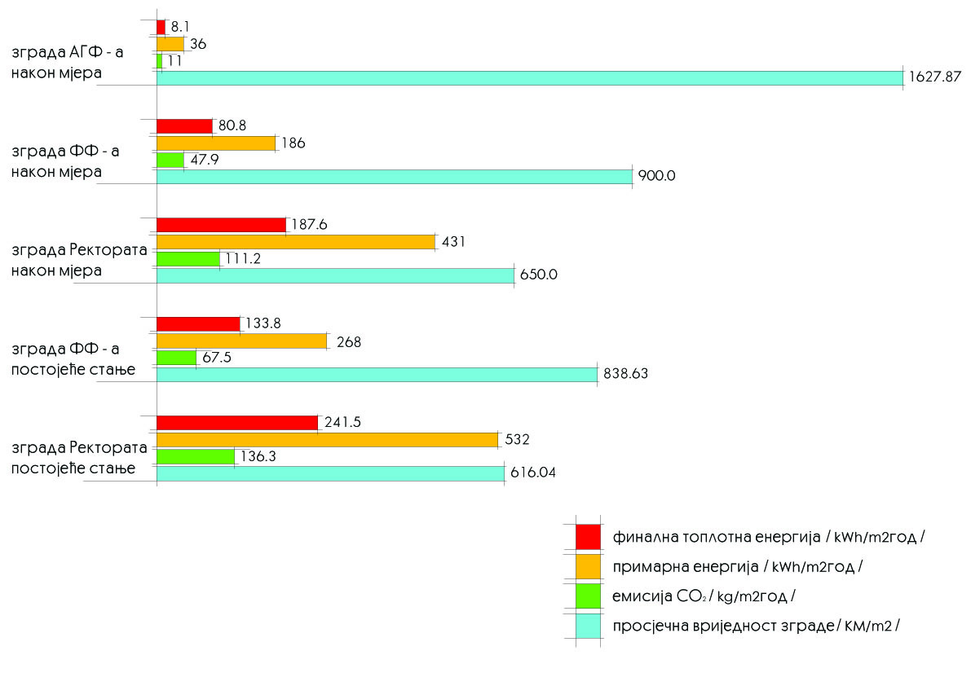
Picture 6. Comparative overview of the final and primary energy consumption, CO₂ emission and average value of the representative samples before and arter applying measues

PLANNED ACTIVITIES AND COMPONENTS
I. Making of NAMA project (period: 2 months)
II. Construction work (period: 24 months)
Planned works on the construction of the FACEG building are divided into four groups:
  - The first group consists of the activities on the closure of the facility, in order to prevent its deterioration and close the outer layer of the object, so as to ensure works that have been performed so far and create preconditions for the works on the interior organisation of the object. This group of works is divided into three subgroups.
- The first subgroup includes works related to the closure of the upper horizontal area of the object. This includes work on all layers of flat roof and terraces, works on the drainage of waste water from the building and part of external development (period: 2 months).
- The second subgroup inludes works on setting up the entire external locks, which includes the construction works on the arrangement of the central glazed hall of the building that until now could have not been carried out due to technological problems (period: 6 months).
- The third subgroup includes the construction of all elements of the exterior facades. These works are performed in order to complete the construction of the outer layer of the object (period: 3 months).
- The second group of works includes the installation of internal locks, the final works on the internal facade of the building in the central part of the glazed hall, the floor mat installation and the remaining locksmith work (stairs and lift). This group of works also involves basic works on all installations in the building (period: 6 months).
- The third group of works are on top coverings and completion of all interior and exterior installations (period 4 months).
- The fourth group includes the exterior works which involve the harmonization of existing project with the Regulatory Plan amendments that are in progress (period: 2 months).
III. Works on the development of a wider outer space (period: 6 months)
This phase of works includes building systems and devices in order to collect and use atmospheric, ground and sanitary waste water, its disposal and recycling. These works are planned as initial steps in the realisation of a larger project of University town development according to BlueGreenDream principles, which include adaptation to climate change in urban systems by exploiting the synergies of water and green structures.
IV. Measurement of CO₂ emission and other ecological parameters (period: 12 months)
V. Reporting (period: 1 month)
VI. Verification (period: 1 month)
It is suggested that the system of measurement, reporting and verification (MRV) is done by independent body nominated by Ministry of Spatial Development, Civil Engineering and Ecology, in cooperation with the Faculty of Architecture, Civil Engineering and Geodesy and University of Banja Luka. It is suggested that MRV is done by Passive House Institute (The Passive House Institute) in Darmstadt, Germany. The Passive House Institute (PHI) is an independent research institute that has played an especially crucial role in the development of the Passive House concept - the only internationally recognised, performance-based energy standard in construction.

PROJECT ACTORS
Table 6. Actors, activities and financial responsibilities
 | ACTORS | Activities  and financial responsibility | TIME
1. | UBL  University of Banja Luka | Construction land (owner) | done
 |  | Existing facility “Teresa“ (owner) | done
 |  | Preparation of tender documents | done
2. | FACEG  Faculty of Architecture, Civil Engineering and Geodesy | Preliminary design | done
 |  | Elaborate on geomechanical investigations | done
 |  | Urban and technical requirements | done
 |  | Location permit | done
 |  | The main project | done
 |  | Exploratory drilling and geothermal works | done
 |  | Elaborate on harmful ionising radiation | done
3. | GRS, FACEG  Republic of Srpska Government | A study on the feasibility, energy efficiency and transfer of knowledge and technology | done
 |  | Building permit | done
 |  | 1st phase of the building construction | done
4. | MSDCEE  Ministry of Spatial Development, Civil Engineering and Ecology | NAMA application approval | 3 months
5. | NAMA support  FACEG  UBL | Building construction,  Ecological systems and devices around the building and surrounding green structures. | 24 months  6 months
6. | MSDCEE  Independent body  FACEG, NAMAdonors | MRVsystem  Measurement of energy and environmental parameters  Reporting and Verification  Promotion of the project and dissemination of knowledge | After 1 year of building functioning

FINANCING STRUCTURE OF THE NAMA PROJECT
In the activities that have been done so far on the construction of FACEG building significant material resources have been invested over the past 5 years that lasts the whole process of making investment аnd technical documentation and the building construction. In the tables below there are the activities and the funding value already invested and financial need for building to be finished.

Table 7. Activities and funding value already invested in building construction
 | Activities | BAM | EUR | $
1. | Construction land – 6.833,70 м² | 1.366.740,00 КМ | 700.892,30 €
2. | Value of the existing facility “Teresa“- 1.890,00 м² | 850.500,00 КМ | 436.153,84 €
3. | Preliminary design | 43.566,72 КМ | 22.341,90 €
4. | Elaborate on geomechanical investigations | 4.500,00 КМ | 2.307,69 €
5. | Urban and technical requirements | 6.200,00 КМ | 3.179,48 €
6. | Location permit | 1.500,00 КМ | 769,23 €
7. | The main project | 159.744,64 КМ | 81.920,32 €
8. | A study on the feasibility, energy efficiency and transfer of knowledge and technology | 257.450,00 КМ | 132.025,64 €
9. | Exploratory drilling and geothermal works | 21.500,00 КМ | 11.025,64 €
10. | Elaborate on harmful ionising radiation | 5.000,00 КМ | 2.564,10 €
11. | Building permit | 827.767,68 КМ | 424.496,24 €
12. | Preparation of tender documents | 4.500,00 КМ | 2.307,69 €
13. | 1st phase of the construction | 2.157.802,85 КМ | 1.106.565,56 €
 | TOTAL | 5.706.771,89 КМ | 2.926.549,68 € | 3.099.110,90 $

Table 8. Overview of the assessment of funding required for the completion of the building – FINANCIAL NEEDS
 | Activities | BAM | EUR | $
 | FIRST PHASE - Construction of the building
1. | I group – first priority - urgent | 641.312,91 КМ | 328.878.41€
2. | I group – second priority | 2.542.568,23 КМ | 1.303.881.14 €
3. | I group – third priority | 1.901.652,83 КМ | 975.206.57 €
4. | II group of works | 2.669.958,83 КМ | 1.369.209.65 €
5. | III group of works | 3.404.734,26 КМ | 1.746.017.56 €
6. | IV group of works | 1.317.222,00 КМ | 675.498.46 €
7. | MRV | 456.622,44 KM | 234.165.35 €
 | TOTAL | 12.934.071,50 КМ | 6.632.857.17 € | 7.023.958,00 $
8. | SECOND PHASE -  Ecological systems and devices around the building and surrounding green structures | 4.655.000,00 КМ | 2.387.179.48 € | 2.527.937,00 $
 | TOTAL | 17.589.071,50 КМ | 9.020.036.66 € | 9.551.895,00 $

Climate Change Adaptation and Low-Emission Development Strategy for Bosnia and Herzegovina, 2013. Adapted by the Council of Ministers of Bosnia and Herzegovina on 08 October 2013.
Climate Change Adaptation and Low-Emission Development Strategy for Bosnia and Herzegovina, 2013, p. 36.
http://bgd.org.uk/
http://bgd.org.uk/
http://www.passiv.de/en/index.php

